**Music World**

**Front Page:-**

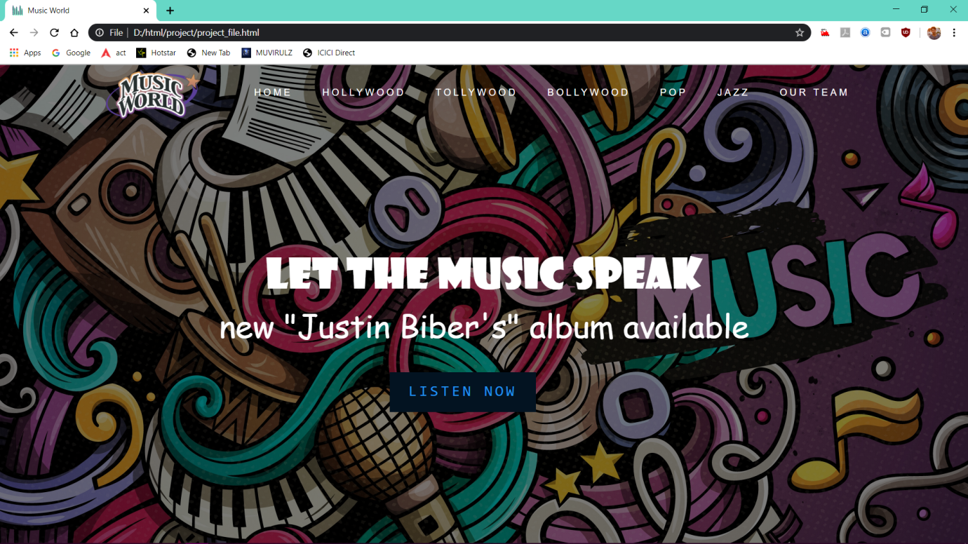

**Introduction:-**

This is the website for online music store. The customer has to login to view his playlist . Random different songs are visible which the person can add to playlist, download, Remove from the viewable list. This website displays all the information about music and various categories of music like: jazz, rock, rap, pop and classical.

In this website There are all type of music’s, songs and also movie albums from Hollywood, Tollywood, Bollywood, Pop and Jazz music’s are also available to listen information about music and various categories of music like: jazz, rock, rap, pop and classical In this website there are more than 100+ music available, It is very user-friendly website, this consists of 7-8 pages.

What is music? Music is a general melody of sounds that unify the mind and soul. Not even language differences can stop music from reaching out to our selected audience. Even before recorded history, people created music, whether through drumming, singing or chanting. Some of our strongest emotions may be brought on by listening to a piece of music. In this modern age, we hear music around us almost all of our waking hours, in one form or another: radio, television or film music and our personal music (iPods, MP3 players, etc.) is with us throughout the day. Most of us listen to recorded music or go to performances regularly.

**Requirement:-**

* **All types of music downloaded with information**
* **Photos of the artist or singer**
* **Website logo**
* **Html**
* **Css**

**Work Load Distribution:-**

**Class section : K19XC**

**Roll no Name Reg no Work**

25 Ashish kumar 11902673 Popular songs download

26 Gunasundar Ram 11901806 front page, photos, sign up page

27 Sushanth Reddy 11902238 rest all pages, Design webpages, logo, synopsis

28 Bhargav Chowdary 11903537 contact us page and information

**Gantt chart:-**

